## Reports/ Rx Reports/ Wait For Drug Report:

Request:

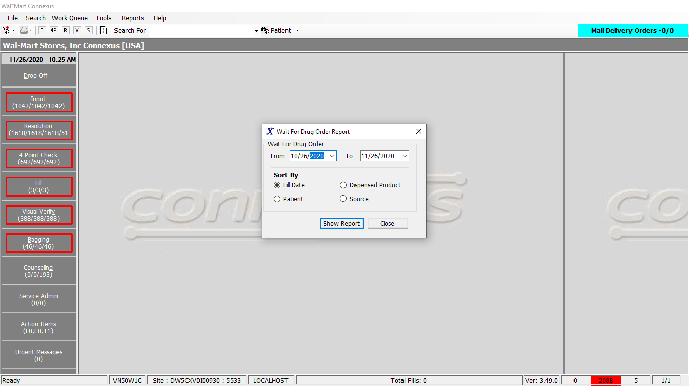

Response:

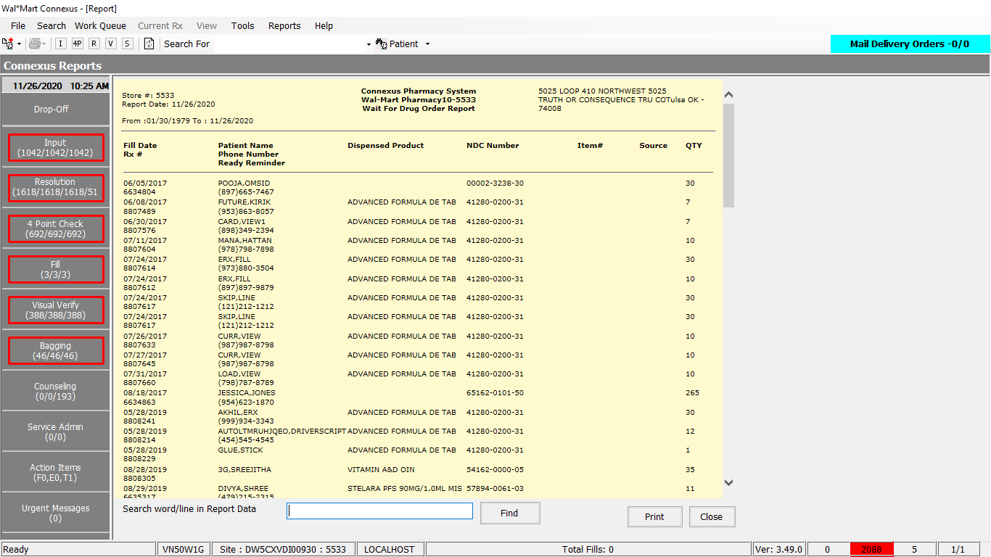

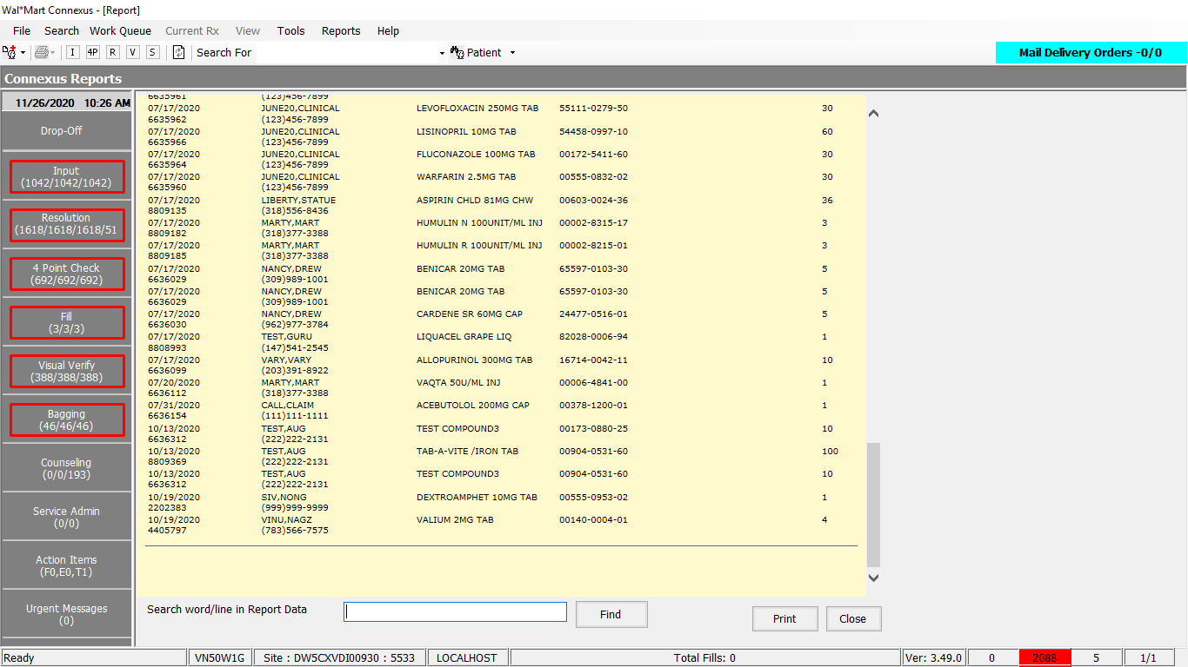

Query:

Friend Const WaitForDrugOrderQuery As String = "SELECT pi.mds_fam_id, rxf.fill_date, trim(nvl(pt.last_name,'')) || ',' || trim(nvl(pt.first_name,'')) || ' ' || trim(nvl(pt.middle_name,'')) Name," &

"pi.ndc_nbr, rx.rx_nbr, piu.item_nbr, TRIM(subc1.communication_id) phone, TRIM(subc2.communication_id) cellphone, pt.patient_id, " &

"CASE WHEN rx.compound_ind = 'Y' THEN " &

" (SELECT comp.compound_name FROM compound comp, rx_compound rxc WHERE rx.rx_id = rxc.rx_id AND rxc.compound_id = comp.compound_id ) " &

" WHEN (rod.request_type_code = 1608 OR rod.request_type_code = 1609 ) THEN " &

" (SELECT DISTINCT drug_name FROM phm_rx_transfer prt WHERE prt.rx_id = rod.rx_id AND prt.transfer_stat_code = 20300 ) " &

" ELSE trim(pp.short_name) " &

"END product_name, " &

"rod.rx_fill_id, rxf.fill_qty " &

"FROM rx_order_detail rod, rx, rx_fill rxf, " &

"OUTER rx_sale_detail rsd, rx_fill_item rfi, patient pt, OUTER subject_comm subc1, " &

"OUTER subject_comm subc2, pharmacy_offering:pharmacy_item pi, " &

"OUTER pharmacy_offering:pharmacy_product pp, rx_ord_dtl_problem rp , " &

"OUTER pharmacy_offering:phm_item_upc piu " &

"WHERE rx.rx_id = rod.rx_id AND rxf.rx_fill_id=rod.rx_fill_id AND rsd.rx_fill_id=rx.last_rx_fill_id " &

"AND rsd.aff_prty_type_code= 1200 " &

"AND rod.status_code= 20501 " &

"AND rod.work_que_stat_code <> 20202 " &

"AND rod.next_work_que_code <> 1 " &

"AND rp.order_id = rod.order_id " &

"AND rp.order_seq_nbr = rod.order_seq_nbr " &

"AND rp.problem_stat_code IN (6300, 6304) " &

"AND rp.problem_seq_nbr = (SELECT min(problem_seq_nbr) FROM rx_ord_dtl_problem rodp WHERE rodp.order_id = rod.order_id " &

"AND rodp.order_seq_nbr = rod.order_seq_nbr " &

"AND rodp.problem_stat_code IN ( 6300, 6304)) " &

"AND pt.patient_id = rx.patient_id " &

"AND rfi.rx_fill_id = rod.rx_fill_id " &

"AND pi.mds_fam_id = rfi.item_mds_fam_id " &

"AND pp.product_mds_fam_id = pi.product_mds_fam_id " &

"AND next_work_que_code= 7 " &

"AND rp.phm_problem_code IN (3012,3007 ) " &

"AND rod.request_type_code <> 1608 " &

"AND rod.request_type_code <> 1609 " &

"AND pi.upc_nbr = piu.upc_nbr " &

"AND piu.prime_status_code = 0 " &

"AND subc1.subject_id = pt.patient_id " &

"AND subc1.subject_type_code = 300 " &

"AND subc1.comm_method_code = 2 " &

"AND subc1.last_change_ts = (SELECT MAX(last_change_ts) from subject_comm WHERE subject_id = pt.patient_id AND subject_type_code = 300 AND comm_method_code = 2) " &

"AND LENGTH(TRIM(subc1.communication_id)) > 0 " &

"AND subc2.subject_id = pt.patient_id " &

"AND subc2.subject_type_code = 300 " &

"AND subc2.comm_method_code = 6 " &

"AND subc2.last_change_ts = (SELECT MAX(last_change_ts) from subject_comm WHERE subject_id = pt.patient_id AND subject_type_code = 300 AND comm_method_code = 6) " &

"AND LENGTH(TRIM(subc2.communication_id)) > 0 " &

"AND rxf.fill_date between ? AND ? "

DAL:

Public Function GetWaitForDrugOrderReport(ByVal siteId As Integer, ByVal startDate As Date,

ByVal endDate As Date,

ByVal sortOrder As Integer) _

As List(Of WaitForDrugOrderBE) Implements IReportDAL.GetWaitForDrugOrderReport

Using (New Tracer(ConnexusCommonConstants.ConnexusTracer))

Dim paramList As New List(Of DbParameter)

Dim sqlString As New StringBuilder

Dim waitForDrugOrderDataList As New List(Of WaitForDrugOrderBE)

Dim piEnabled As Boolean = If(ReportDAL.GetBUPhmParm(siteId, ServicesCommonConstants.PiEnabled).Trim.ToUpper(CultureInfo.InvariantCulture) = "TRUE", True, False)

Dim isStoreOrderType As Boolean = If(ReportDAL.GetBUPhmParm(siteId, 10723).Trim.ToUpper(CultureInfo.InvariantCulture) = "TRUE", True, False)

Dim autoOrderMethod As String = ReportDAL.GetBUPhmParm(siteId, 10718).Trim.ToUpper(CultureInfo.InvariantCulture)

paramList.AddParameter(DbType.Date, startDate, "startDate")

paramList.AddParameter(DbType.Date, endDate, "endDate")

sqlString.Append(ReportQueries.WaitForDrugOrderQuery)

If sortOrder = WaitForDrugOrderReportSortOption.FillDate Then ' sort by fill date

sqlString.Append(" ORDER BY rxf.fill_date,pt.last_name;")

ElseIf sortOrder = WaitForDrugOrderReportSortOption.Patient Then ' sort by patient name

sqlString.Append(" ORDER BY pt.last_name,pt.first_name; ")

ElseIf sortOrder = WaitForDrugOrderReportSortOption.Product Then 'Sort by product Name

sqlString.Append(" ORDER BY product_name; ")

End If

Dim dataReader As IDataReader = ExecuteReader(DatabaseEnum.rx21c, siteId,

sqlString.ToString, paramList)

Dim waitForDrugOrderBE As WaitForDrugOrderBE

While dataReader.Read

waitForDrugOrderBE = New WaitForDrugOrderBE

waitForDrugOrderBE.MdsFamID = SafeConvert.ToInteger32(dataReader.GetValue(dataReader.GetOrdinal("mds_fam_id")))

waitForDrugOrderBE.DispensedProduct = SafeConvert.ToString(dataReader.GetValue(dataReader.GetOrdinal("product_name")))

waitForDrugOrderBE.FillDate = SafeConvert.ToDateTime(dataReader.GetValue(dataReader.GetOrdinal("fill_date")))

waitForDrugOrderBE.Quantity = SafeConvert.ToDecimal(dataReader.GetValue(dataReader.GetOrdinal("fill_qty")))

waitForDrugOrderBE.PatientName = SafeConvert.ToString(dataReader.GetValue(dataReader.GetOrdinal("name")))

waitForDrugOrderBE.RxNumber = SafeConvert.ToInteger32(dataReader.GetValue(dataReader.GetOrdinal("rx_nbr")))

waitForDrugOrderBE.ItemNumber = SafeConvert.ToInteger32(dataReader.GetValue(dataReader.GetOrdinal("item_nbr")))

waitForDrugOrderBE.NdcNumber = SafeConvert.ToString(dataReader.GetValue(dataReader.GetOrdinal("ndc_nbr")))

waitForDrugOrderBE.PhoneNumber = SafeConvert.ToString(dataReader.GetValue(dataReader.GetOrdinal("phone")))

waitForDrugOrderBE.ReadyReminder = SafeConvert.ToString(dataReader.GetValue(dataReader.GetOrdinal("cellphone")))

'Get Supplier based on PIEnabled flag

If piEnabled AndAlso Not isStoreOrderType AndAlso (autoOrderMethod IsNot Nothing AndAlso (autoOrderMethod.Equals("SR") Or autoOrderMethod.Equals("ITEM"))) Then

Dim supplierInfo As List(Of GetPIPrimarySupplierInfoBE) = ItemHelper.GetPIPrimarySupplier(siteId, waitForDrugOrderBE.MdsFamID)

If supplierInfo.HasRecords Then

waitForDrugOrderBE.Source = supplierInfo(0).SupplierAbbr

'waitForDrugOrderBE.ItemNumber = supplierInfo(0).PreferredSupplierNbr

End If

Else

Dim supplierInfo As List(Of GetPrimarySupplierInfoBE) = ItemHelper.GetPrimarySupplier(siteId, waitForDrugOrderBE.MdsFamID)

If supplierInfo.HasRecords Then

waitForDrugOrderBE.Source = supplierInfo(0).CoAbbr

waitForDrugOrderBE.ItemNumber = SafeConvert.ToInteger32(supplierInfo(0).SupplierReference)

End If

End If

waitForDrugOrderDataList.Add(waitForDrugOrderBE)

End While

If waitForDrugOrderDataList.Count > 0 Then

Return waitForDrugOrderDataList

Else

Return Nothing

End If

End Using

End Function